Part C — Coding
Q1.
Write Python code to perform the following steps:
- Segment into tokens
- Remove stopwords
- Apply lemmatization (not stemming)
- Keep only verbs and nouns (use POS tags)
Input text:
"John enjoys playing football while Mary loves reading books in the library."
Code:
import nltk
from nltk.corpus import stopwords
from nltk.stem import WordNetLemmatizer
from nltk import word_tokenize, pos_tag

# ✅ Download all required NLTK resources
nltk.download('punkt')
nltk.download('punkt_tab') # new in NLTK ≥3.9
nltk.download('averaged_perceptron_tagger')
nltk.download('averaged_perceptron_tagger_eng') # new tagger model name
nltk.download('wordnet')
nltk.download('stopwords')
nltk.download('omw-1.4')

# Input text
text = "John enjoys playing football while Mary loves reading books in the library."

# Step 1: Tokenization
tokens = word_tokenize(text)

# Step 2: Remove stopwords and non-alphabetic tokens
stop_words = set(stopwords.words('english'))
filtered_tokens = [w for w in tokens if w.lower() not in stop_words and w.isalpha()]

# Step 3: Lemmatization
lemmatizer = WordNetLemmatizer()

# Helper function to map POS tags for lemmatization
def get_wordnet_pos(tag):
if tag.startswith('J'):
return 'a' # adjective
elif tag.startswith('V'):
return 'v' # verb
elif tag.startswith('N'):
return 'n' # noun
elif tag.startswith('R'):
return 'r' # adverb
else:
return None

# Step 4: POS tagging
pos_tags = pos_tag(filtered_tokens)

# Step 5: Lemmatize and keep only nouns & verbs
final_words = []
for word, tag in pos_tags:
wn_tag = get_wordnet_pos(tag)
if wn_tag in ('n', 'v'): # keep only nouns and verbs
lemma = lemmatizer.lemmatize(word.lower(), wn_tag)
final_words.append(lemma)

print("Final output tokens:", final_words)

Output:
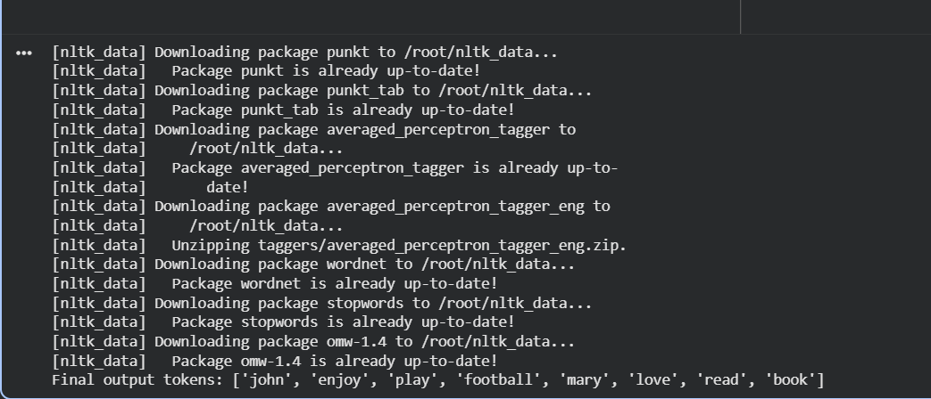

Q2.
Use Python and any NLP model to perform:
- Named Entity Recognition (NER)
- Disambiguation prompt:
If the text contains a pronoun ("he", "she", "they"), print:
"Warning: Possible pronoun ambiguity detected!"
Input text:
"Chris met Alex at Apple headquarters in California. He told him about the new iPhone launch."
Code:
import spacy

# Load English NLP model (small, fast, and pre-trained)
nlp = spacy.load("en_core_web_sm")

# Input text
text = "Chris met Alex at Apple headquarters in California. He told him about the new iPhone launch."

# Process text through spaCy pipeline
doc = nlp(text)

# 1️⃣ Named Entity Recognition (NER)
print("=== Named Entities ===")
for ent in doc.ents:
print(f"{ent.text} --> {ent.label_}")

# 2️⃣ Pronoun Disambiguation Warning
pronouns = {"he", "she", "they", "him", "her", "them"}
tokens_lower = [token.text.lower() for token in doc]

if any(p in tokens_lower for p in pronouns):
print("\n⚠️ Warning: Possible pronoun ambiguity detected!")
else:
print("\nNo pronoun ambiguity detected.")

Output:
